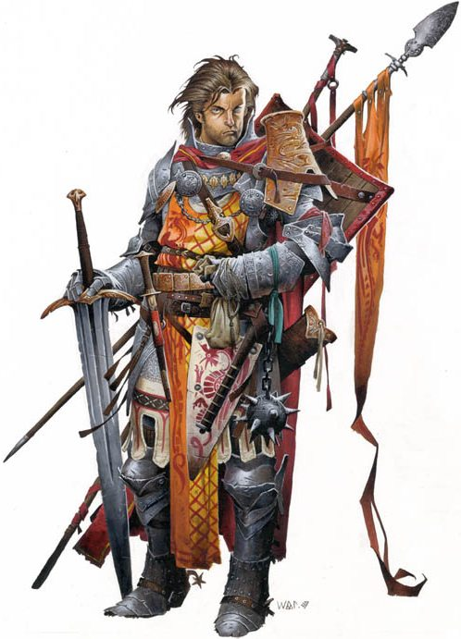

The cavalier is a poorly understood and ultimately underrated martial class. Many will look at it and come to think of the cavalier as some cruddy version of the paladin.

Nothing could be farther from the truth.

While the similarities in abilities do bring to mind a principled warrior astride his mighty steed leading his comrades from the frontline against impossible odds I believe that was in fact the point. Unbeholden to any code or god except that which he has chosen to live, a cavalier is much more flexible and less rigid than a paladin. Cavaliers can be heroes for the king, for their god, for the common man, for the ideals of freedom and justice. Alternatively, they can be the blackest of villains.

So just what is a cavalier?

A Frontline Combatant: Between the d10 hit dice, the proficiencies, challenge, and the bonus combat feats it’s obvious that the cavalier was meant to hit things and hit them hard. Certain orders even go further and make them truly terrible frontline brutes.

A Mounted Terror: If cavaliers have one thing over every other martial class it is that they are the only ones that come out of the box with a full druid companion ready to go. Combined with his other abilities this makes him unparalleled on horseback (or Dinosaur back). When a cavalier decides to mount up and charge a target he’s challenged that target doesn’t last long enough to regret meeting him.

A Support Character: Even though a single mounted cavalier is a terror to behold on the battlefield they truly shine when they have others to share in the glory (yes even Order of the Cockatrice cavaliers). Tactician can easily be one of the best actions in the game for the right party. And every order has an ability that can benefit his peers.

Ultimately cavaliers don’t operate well in a vacuum. Be it their mount, their flanking partner, or a fellow who has lifted his blade to their cause cavaliers are simply at their best when fighting alongside another warm body. Unlike most martial classes a cavalier’s overall ability seems to increase with the number of peers around him making him an excellent partner for any other melee class.

With all this being said let’s dive into the cavalier and discuss the details. Like all the other guys I’ll be using a color coded system. Blue for options that are must haves, generally for the purpose it is being put toward. Green is for abilities that are really good but not absolutely amazing. Orange is for options that, while okay, generally fit into some situational category or are simply not as strong as a green or blue option. Red is a weak choice that can break a build either by being far too situational or far too weak.

The Cavalier At a Glance: Breakdown and Race choice
Orders
The Care and Feeding of your Mount
Archetypes
Combat Styles
Prestige Class options
Equipment(OUTDATED)

